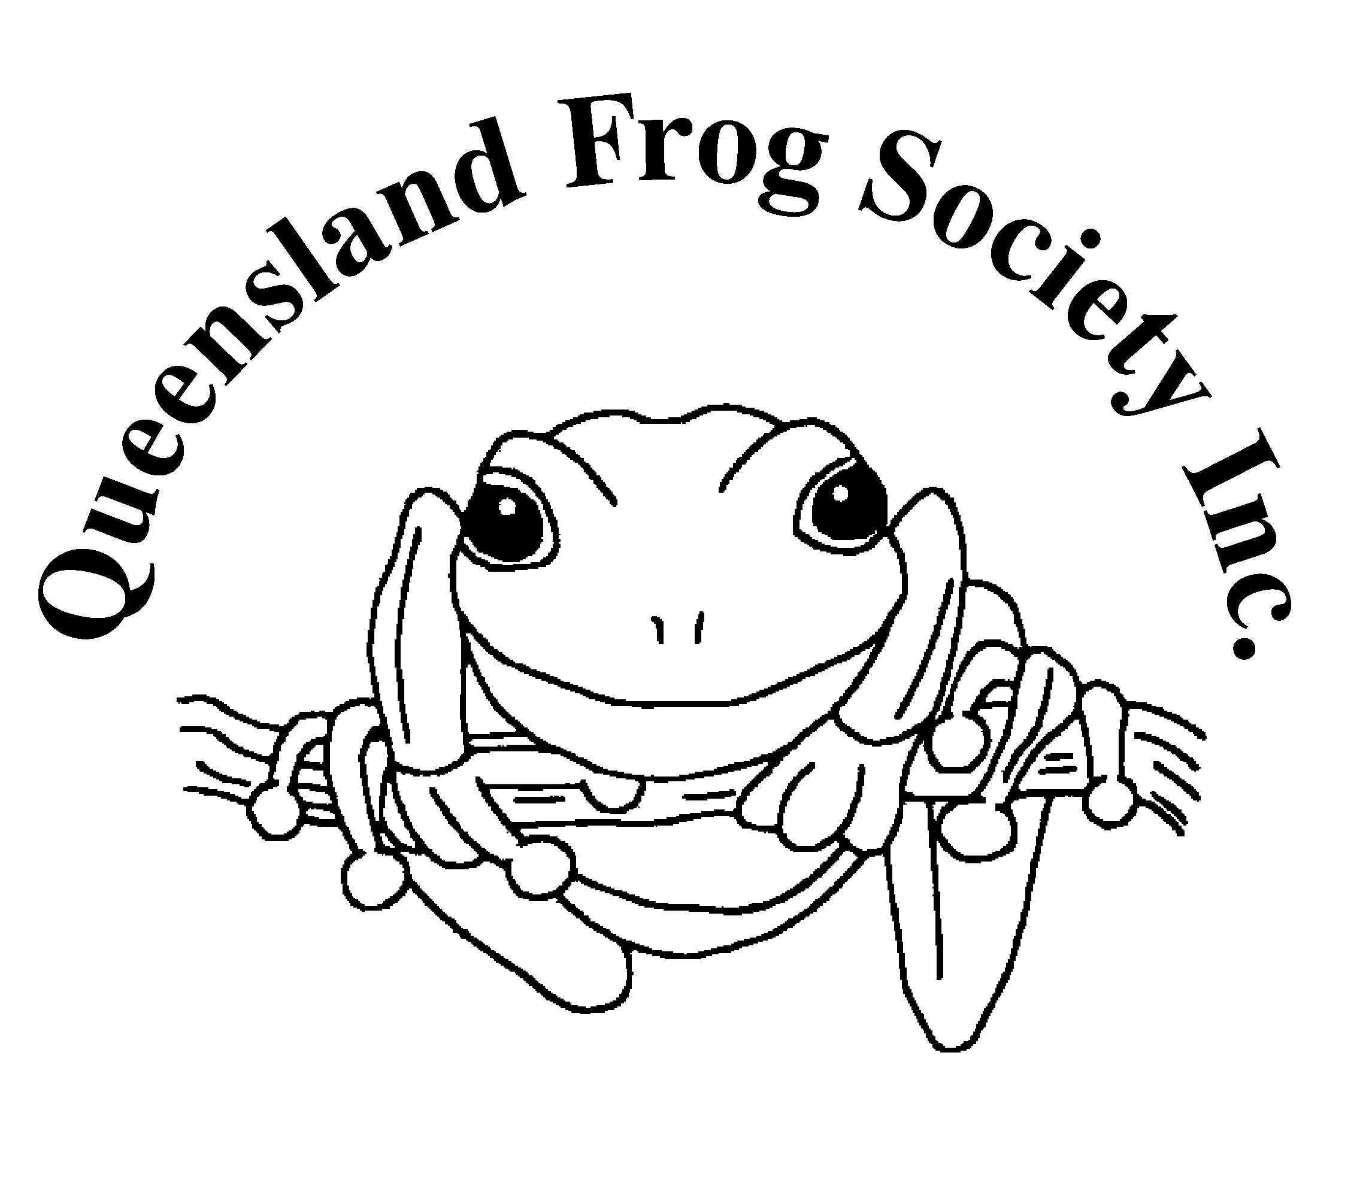
QUEENSLAND FROG SOCIETY Inc

QUEENSLAND FROG SOCIETY TRUST FUND
RIC NATTRASS RESEARCH GRANT 2022
INFORMATION FOR APPLICANTS

The Queensland Frog Society Inc was established to encourage and foster a public awareness of and an interest in frogs. In 1999 the Queensland Frog Society Trust Fund was established to support the environmental aims of the society.

Applications are called for the 2022 Queensland Frog Society Trust Fund Ric Nattrass Research Grant. One grant of $1500 is available. The purpose of the grant is to assist research into Queensland’s frogs.

Selection for funding will be made by a committee comprised of a trustee of the fund or their representative, a QFS committee member and a biologist (from academia or Department of Environment and Science (DES)).

Conditions
Applicants must be a resident in Australia.

The grant must be used for research expenses such as writing up, field travel, running costs of project, consumables, equipment hire or purchase (not for salaries).

Applicants must be current financial members of the Queensland Frog Society but may not be QFS management committee office bearers.

Applications must be received by email by 11 February 2022 or postmarked no later than that date. Applicants will be informed by mid-March of the outcome of their application.

Applicants not enrolled at an educational institution must be able to demonstrate in their application that they have the scientific competence to undertake and complete the proposed research project.

It is expected that grantees will obtain permission from landholders where the research will be undertaken. Grantees are expected to comply with all State and Commonwealth regulations, including obtaining relevant wildlife permits and animal care and ethics approval, copies of which must be attached.

Grantees must give an oral presentation of their work to the Society (within 18 months of being awarded the grant) and submit a brief report for inclusion in the society’s newsletter, Frogsheet. A copy of any report (written, poster or audiovisual), thesis or publication arising from the work must be provided to QFS.

Grantees are requested to acknowledge the society’s support in any presentations or publications arising from their project.

Apply by sending application form (page 2) with attachments (as described on page 3).

QUEENSLAND FROG SOCIETY TRUST FUND
RIC NATTRASS RESEARCH GRANT 2022

APPLICATION FORM

Family Name: | Other Names:
Address:

Postcode:
Phone Numbers:

Email: (please print clearly):

Research Institution (if applicable):

Research degree being pursued (if applicable):

Supervisor (if applicable) and contact details (phone or email)

Expected Duration of project: |  | Year of completion:
Proposed use of funds:

Other sources of funding (if applicable):

Targeted research publications (if applicable):
Abstract title:
Abstract – please describe your proposed research (not more than 300 words) including aims and justification, methods, progress made to date, conservation significance of the work and how your project will benefit frogs in Queensland.
Attach separate sheet.

Declaration by applicant
I have read the conditions governing the Queensland Frog Society Research Grant as given in the document ‘Information for Applicants’ and I agree to abide by them. The information given above is correct to the best of my knowledge. I understand that if I provide incorrect or incomplete information this may result in the cancellation of any offer made by QFS Inc.

Signature:

Date:

QUEENSLAND FROG SOCIETY TRUST FUND
RIC NATTRASS RESEARCH GRANT 2022

ATTACHMENTS
Please attach
- a one page CV
- a letter of support from supervisor/supporter verifying that the project has
been represented accurately (and that the Institution is prepared to administer the award, if applicable).
- copy of relevant wildlife permits, animal care and ethics approval, if applicable.

CHECKLIST
I have:
- Read the Information for Applicants
- Ensured my subscription to the QFS is paid for the year of the grant
- Signed the declaration at the end of the Application Form

If applying by post I have:
- Enclosed Original signed application form, plus 2 copies of:
  - Signed application form
  - Abstract
  - CV
  - Letter of support
  - Copy of relevant permits, if applicable.

Send to: -
The Secretary,
Queensland Frog Society Inc.,
PO Box 7017
East Brisbane 4169

If applying by email I have attached the following: -
  - Signed application form (scanned)
  - Abstract
  - CV
  - Letter of support
  - Copy of relevant permits, if applicable.

in a file named YOURNAME_QFSGRANT_2022

Email to qldfrogs@bigpond.net.au

QFS Privacy Statement
QFS will collect, store and use personal information from applicants only for the purposes of administering applications/grants from prospective/selected grantees. The information collected is confidential, will be securely stored and will only be available to the selection panel and the QFS committee. It will not be disclosed to third parties without your consent, except to meet government, legal or other regulatory authority requirements.

